The Gray Wolf
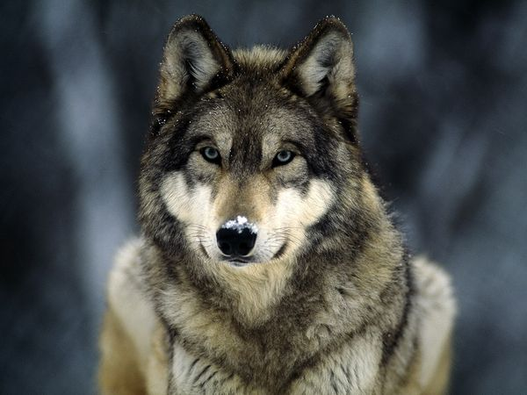

Brandon Hill

Size and Life Span
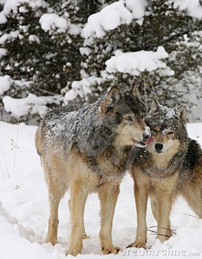
- Largest wild dog species
- Males are usually larger than female
  - 50 - 176 pounds
  - 34 inches to 51 inches
- May live 13 years in the wild
  - Average is 5-6 years
- May live to be 15 years old in captivity

Coat
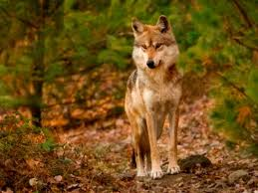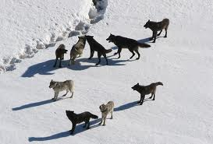

- Depends on where they live
- White in the Arctic’s to white and gray, brown, cinnamon and black
- Their upper parts are usually darker and lighter on their bellies
- Their tail is tipped with black
- They have a thick under fur layer that acts like insulation
  - Like a winter coat

Habitat
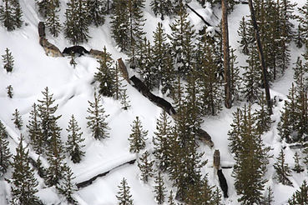
- Wide variety of habitats
  - Arctic tundra to forest, prairie, and arid landscapes

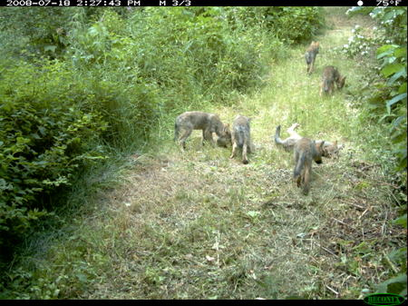
-

Having a family
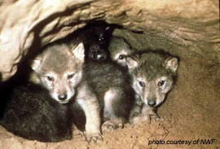

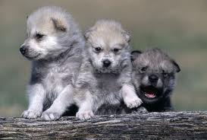

- Females choose their mate and form a lifelong bond
- The female digs a den to have a raise the puppies in
  - Can have between 5 – 14 pups
    - Usually only has 7

Behavior
- Wolves are very social
- They live in packs
  - Packs = 2 – 36 wolves
    - The size of the pack depends on habitat and the amount of food.
    - Territory of a pack ranges from 130 – 13,000 square kilometers and is protected against intruders
  - Most packs are made of 5 – 9 wolves
    - The alpha male and female and their kids
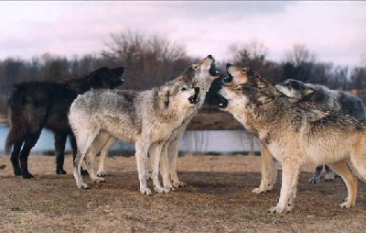

- Very dominant
  - Have ranks or positions in their packs
    - 1. Alpha male, 2. Alpha female,
  - A wolf’s rank in its pack determines which mate and which eat first.
Communication
- By body language and facial expressions
  - Crouching, chin touching, rolling over to show their stomach
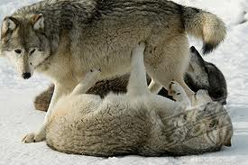

- Vocalizations
  - Howling
    - Where they are
    - When they should meet for pack hunts
    - Tell other packs where the boundaries of their territories are

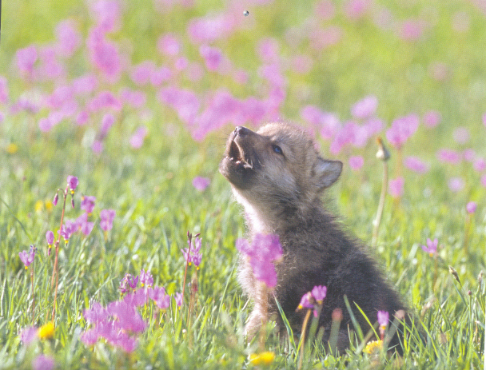

- Scent marking
  - Done by the alpha male
    - To communicate with other packs

Prey
- Wolves are carnivores.
- They hunt on their own, in packs, steal the prey of other predators, or scavenge carrion.
- They find their prey by chance or scent.
- What they eat depends on where they live and what is available to them.
- They hunt in packs for large prey
  - Moose, elk, bison, musk oxen, and reindeer
- They hunt alone for smaller prey
  - Beavers, rabbits, and other smaller mammals
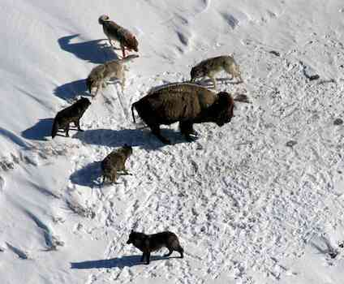
- Usually eat entire carcass
- Wolves may eat livestock and garbage when it is available.
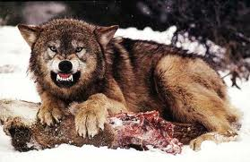

Being the prey
- Few animals prey on gray wolves
  - They are top predators
- Wolves and coyotes are highly territorial. Wolves from other packs and coyotes will attack wolves that are alone or young. They will kill the pups if they find them.
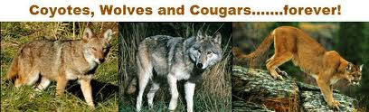

Humans are wolves’ greatest enemy

Endangered
- U.S. Federal list
  - Endangered
- State of Michigan List
  - Threatened
- By the early part of this century man had almost wiped the wolf from the lower 48 states
  - About 2,600 exist now
    - 2,000 in Minnesota
- The main cause of the decline in wolf numbers has been habitat destruction and humans killing them.
- Successful plans to rebuild the numbers has increase population
  - Alaska: 6,000-8,000
  - Canada: about 50,000

Classification
Kingdom: Animalia
Phylum: Chordate
Class: Mammalia
Order: Carnivora
Family: Canidae
Genus Species: Canis lupus

